**The Role of The Nucleus in Collective Cell Migration**

Mid Semester Progress Report

*Presented By:* Brady Hine

*For Partial Completion of:* MECH 498B

*Presented On:* February 28th, 2022

*Committee Members:* Dr. Ghosh, Dr. McGilvray, Dr. Puttlitz

*Word Count:* 1686

Table of Contents

Introduction & Specific Aims 2

Work Accomplished Fall 2021 3

Aim 1 – Assay Establishment 3

Work Accomplished Jan. – Feb. 2021 6

Aim 1 – Control Parameters 6

Aim 1 – Assay Validation 6

Aim 2 – Fixed Cell Data Collection 9

Work Remaining 11

# Introduction & Specific Aims

Cell migration is a fundamental process in normal physiology and pathology. The cell nucleus is emerging as a key mediator in this process. Being the largest and stiffest organelle in eukaryotic cells, the nucleus acts as a limiting factor during cell migration. The role of nuclear mechanics in cell migration is therefore a topic of recent interest to both the basic science and clinical research communities. The objective of the proposed work is to study how nuclear mechanical properties affect collective cell migration using a model system of the scratch wound assay. Quantitative understanding of collective cell migration will be obtained using live time lapse imaging of cells with modified nuclear stiffness and altered chromatin remodeling abilities.

**Specific Aim #1: Establish a scratch wound assay of cell migration using NIH-3T3 cells.** NIH-3T3 mouse embryonic fibroblast cells will be used in this study because they are an excellent model system for this assay and easy to culture. Establishment of a scratch wound assay will involve culturing of the cells in a confluent manner and applying the scratch in a consistent manner. Migration parameters such as speed and persistence will then be quantified using the image processing software Fiji. Determining these image processing methods will also be needed for Aim 2. The assay technique will then be validated using one or two migration inhibitors such as cyto-D to inhibit F-actin or Y27632 to inhibit actomyosin contraction.

**Specific Aim #2: Observe how changes to nuclear mechanics affect migration parameters.** After establishing the control, drugs such as Trichostatin A and GSK126 will be applied to the NIH-3T3 cells which will modify their nuclear stiffness and chromatin remodeling ability. These cells will then undergo the scratch wound assay established in Aim 1. Subsequently, migration parameters will be quantified using image processing and will be compared to the results found in the control group.

**Specific Aim #3: Perform live imaging of the cytoskeleton and nucleus at high resolution to quantify a strain map in the cell monolayer.** The scratch wound assay will be repeated for both the control and modified groups with visualization of the cell cytoskeleton and nucleus using live staining of actin and DNA, respectively. Live imaging at a high resolution will then be performed on these cells during migration. Using image processing, a strain map will be generated at the cell monolayer providing detailed mechanical insight of subcellular mechanics in the cell migration process.

Determining the effects of nuclear mechanical properties on cell migration, and how these effects pertain to the cell monolayer, will help increase our understanding of this fundamental physiological process. If the aims of this project are successfully met, it would help lay groundwork for further studies in understanding the synergistic role of nuclear mechanics with cell crowding effects and differing substrate mechanics applicable in tissue engineering applications.

# Work Accomplished Fall 2021

## Aim 1 – Assay Establishment

The first step of establishing the assay was determining the culturing time to reach confluency in the 8-well plates, observed to be between one and three days. Next, a repeatable method was needed for applying the scratch wound with edges as straight as possible. This was accomplished using a pipette tip to apply the scratch guided by a straight edge. Then from preliminary studies, it was determined that an optimal timeframe for migration imaging after scratch application was around 12 hours. Further progress was made establishing cell staining methods for actin and the nucleus in both live and fixed cells. Staining of fixed cells, using DAPI and Phalloidin, allowed for observation of cell morphology and density in the wound more clearly at a given time point. Meanwhile, staining of live cells using NucBlue and Lifeact allows for easier tracking during the wound healing process. Different live and fixed stains are required due to live stains needing to be small enough to fit through pores in live cells whereas fixed cells may be permeabilized to apply the stains. The impact of these techniques can be seen in figure 1 below with left side showing the first scratch attempt with no migration compared to the right with cleaner edges, fixed cell staining, and observable wound migration.

(Figure 1: Freehand scratch (left) in brightfield view and guided scratch (right) with fixed cell staining of actin in green and nucleus in blue)

Final efforts of the semester focused on processing collected data specifically using automated cell tracking. This was accomplished using ImageJ software and the plugin TrackMate and imaging of a single well scratch wound assay was used to determine the ideal setup of the software for this application. A sample output developed with the workflow is shown below in figure 2 where DAPI stained nuclei are shown as white dots. These nuclei are then recognized by the software and tagged with a purple ring tracking single cell tracks over multiple frames. From here, migration parameters can be obtained by applying known scaling of the images and the time intervals between frames.

(Figure 2: TrackMate path visualization for cells migrating within the wound. Cell nuclei are shown in white with spots detected shown as purple rings. Paths are colorized to show distinction between each other.)

# Work Accomplished Jan. – Feb. 2021

## Aim 1 – Control Parameters

The scratch wound assay established last semester was used to collect baseline migration data for the control NIH-3T3 cells this semester. In the 8-well plate, two wells exhibited extensive cell death during culture and thus data was only recorded from six of the wells. The dataset showed non-normal distributions for the parameters of interest leading us to take a median based approach to the data. These control parameters can be seen in the violin plots of figure 3 below showing mean cell speed on the left and linearity of forward progression on the right. These plots show that the control cells exhibit similar values for the parameters across the different wells and will serve as a baseline to compare the modified cells to in aim 2.

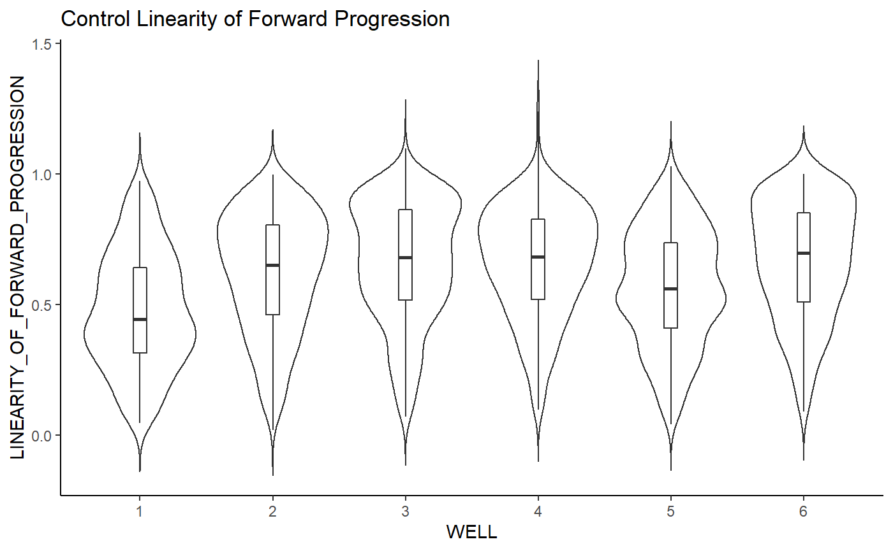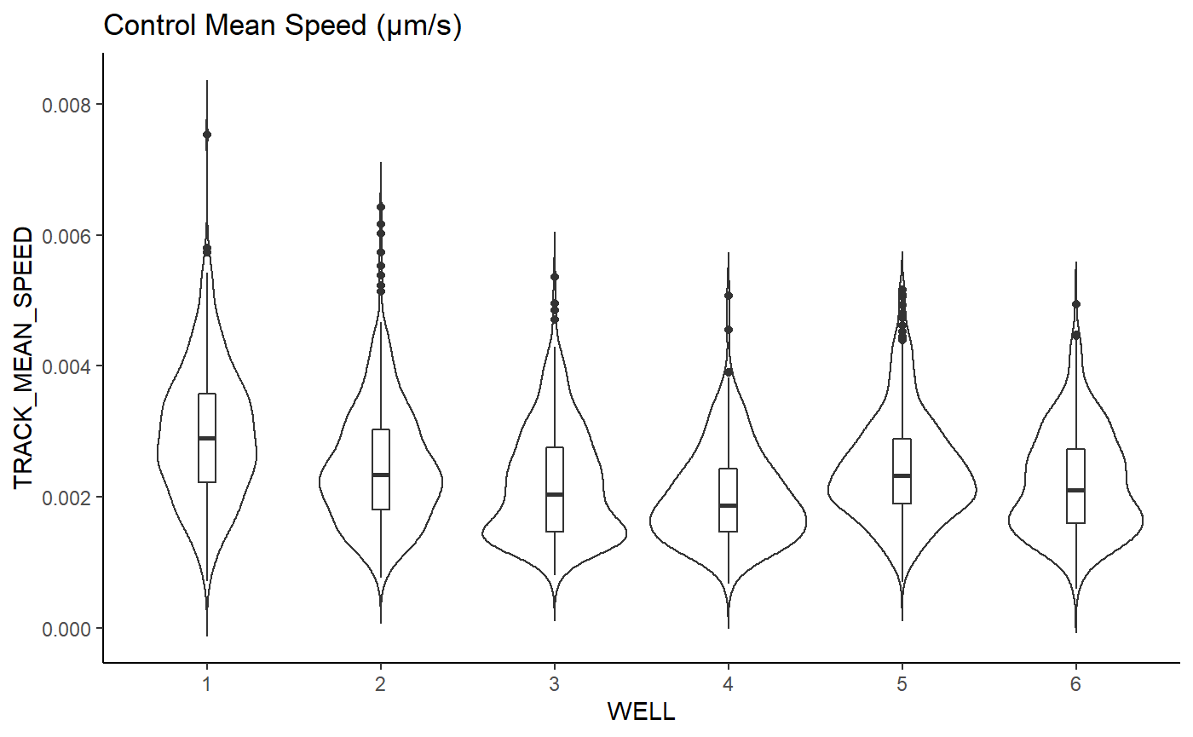

(Figure 3: Violin plots for 6 control wells of the assay measuring cell mean speed (left) and linearity of forward progression (right))

## Aim 1 – Assay Validation

A large portion of time this semester has been spent on validating the assay setup due to cell culturing setbacks. Entire cultures were exhibiting cell death prior to any scratch or drug application which we initially tried to troubleshoot using an earlier passage of NIH-3T3 cells. However, this had no effect pointing to the issue possibly being contamination in an apparatus used for the cell culture. Thus, a deep clean of the water baths, fume hoods, and incubators was conducted which was able to remedy the issue. Until this point the 8 well plates being used were ibidi ibitreat wells offering surfaces optimized for cell adhesion. However, issues in supply chains made these well plates difficult to come across and thus a nontreated 8 well plate was used, and a layer of collagen was applied to offer cell adhesion sites for the NIH-3T3 cells. Upon repeating the assay, it was surprisingly found that this accelerated the wound healing process as after 12 hours the control scratch had completely healed compared to the initial setup.

From here another culture was started and after reaching confluency, some wells were left as a control while the others were treated with a 20μM concentration of Y27632 to inhibit actomyosin contractility. The scratch was then applied to all wells at the same time and live imaging was used to generate figure 4 after four hours. Here it is shown that Y27 application largely reduced observable migration compared to the control. These results validate the test setup by showing that blocking actomyosin contraction indeed slows down the cell migration.

200μm

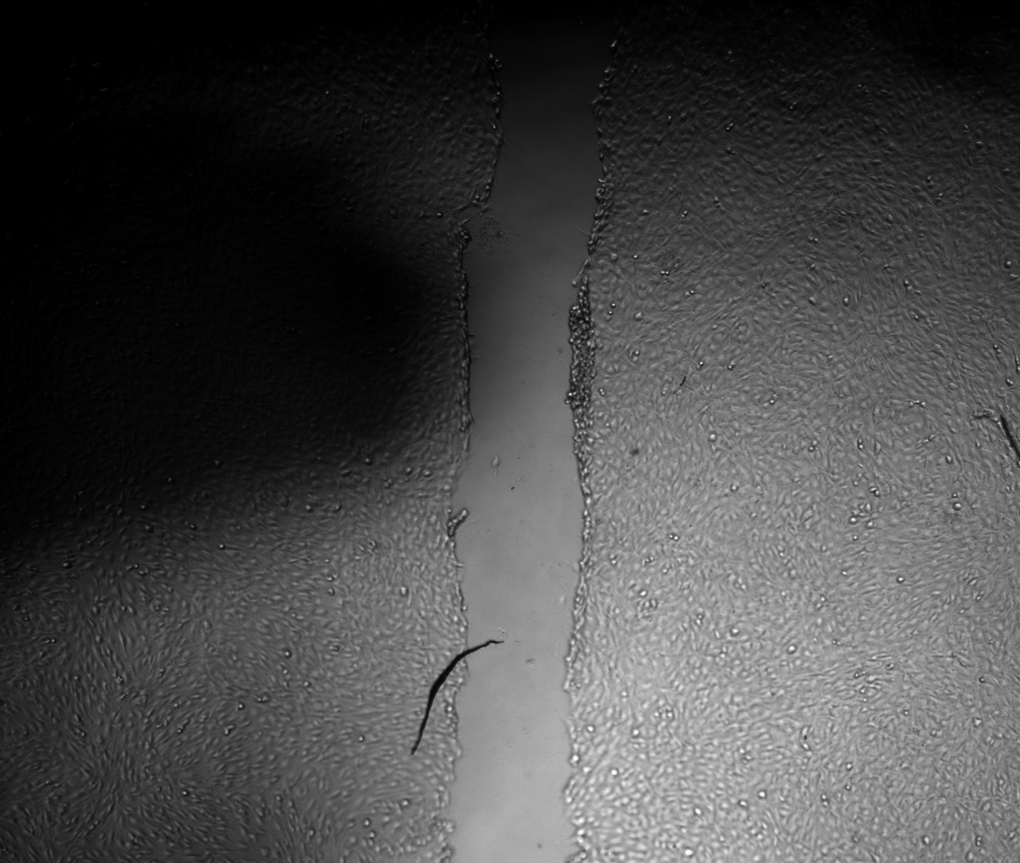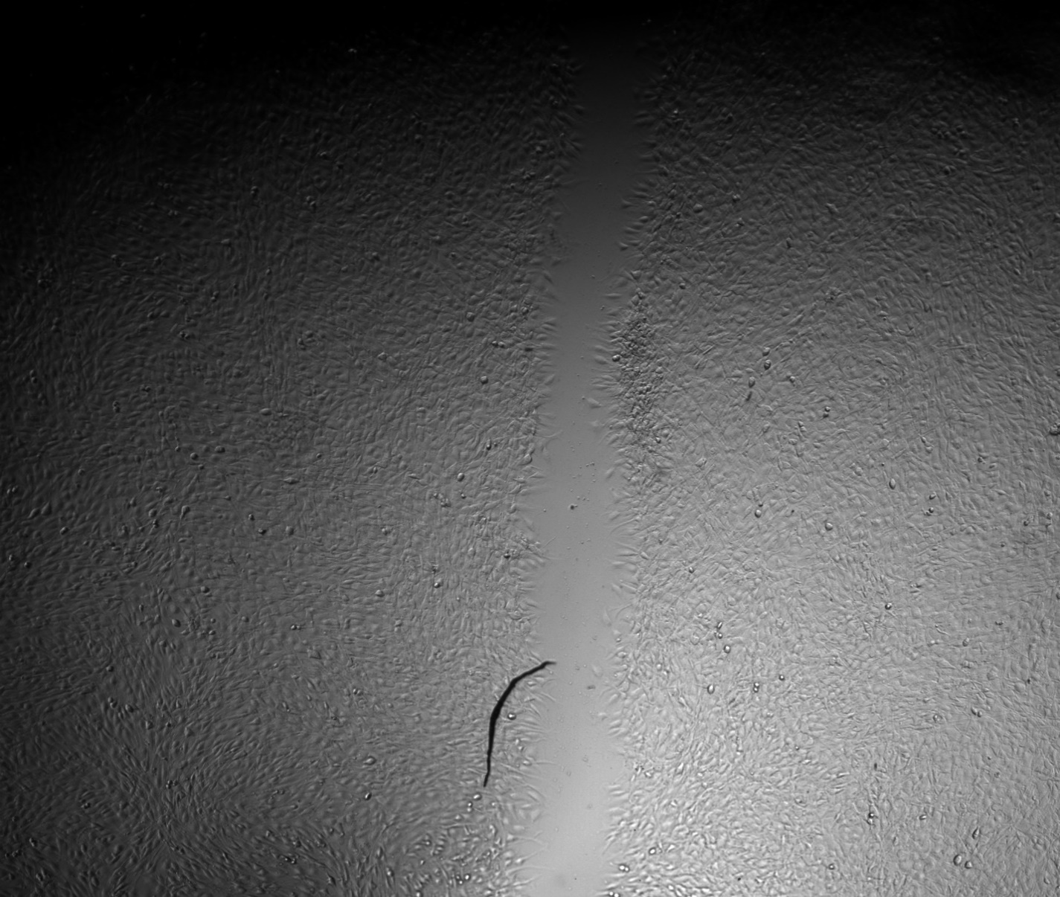

0 hours after scratch

4 hours after scratch

Control Group

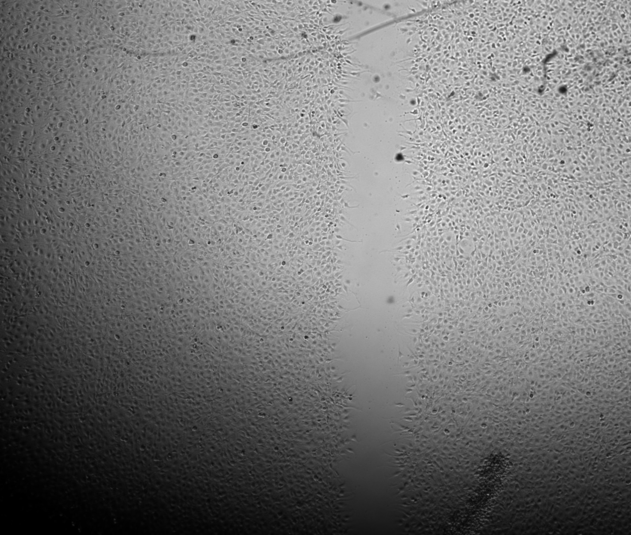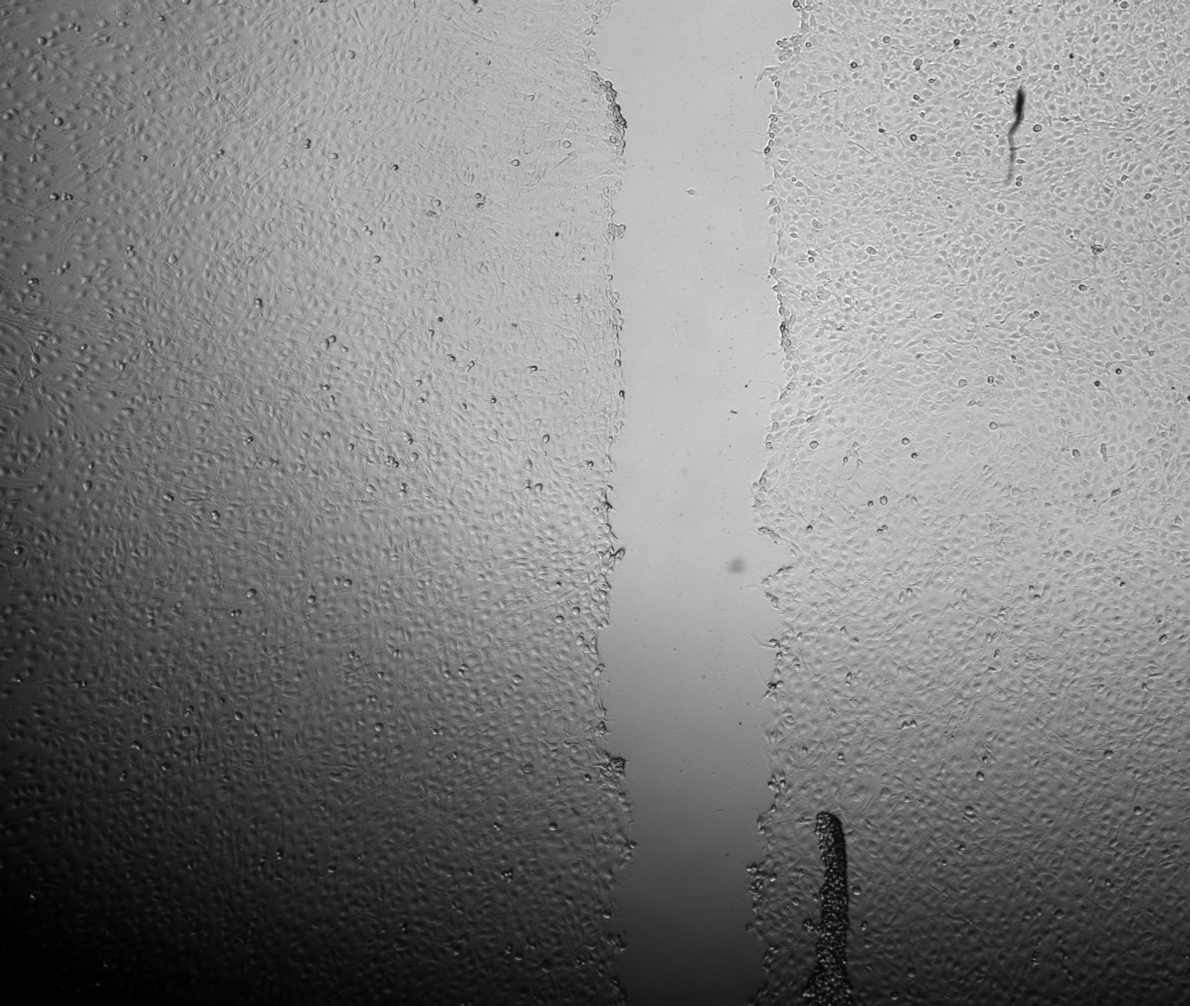

20μM Y27632

(Figure 4: Fixed images of control NIH-3T3 cells (top) and those treated with a 20μM concentration of Y27632 (bottom) immediately after and four hours after scratching)

## Aim 2 – Fixed Cell Data Collection

Aim 2 looks at using Trichostatin A (TSA) and GSK126 to modify nuclear mechanical stiffness and chromatin remodeling and observe changes to migration. Prior to performing a full live imaging analysis for these treatments, a fixed time point analysis was used to see if there were any clear observable changes compared to the control at a specific timepoint of the migration process. Here cells underwent the same experiment shown in figure 4, but treatment was done with 20μM GSK126 and 100 ng/mL TSA. Live images of the migration process after four hours are shown below in figure 5. Here a large increase in observable migration was observed with the application of GSK126 compared to the control group of figure 4 which was expected. Interestingly though, treatment with TSA yielded diminished migration even below levels with Y27632 treatment from visual analysis.

200μm

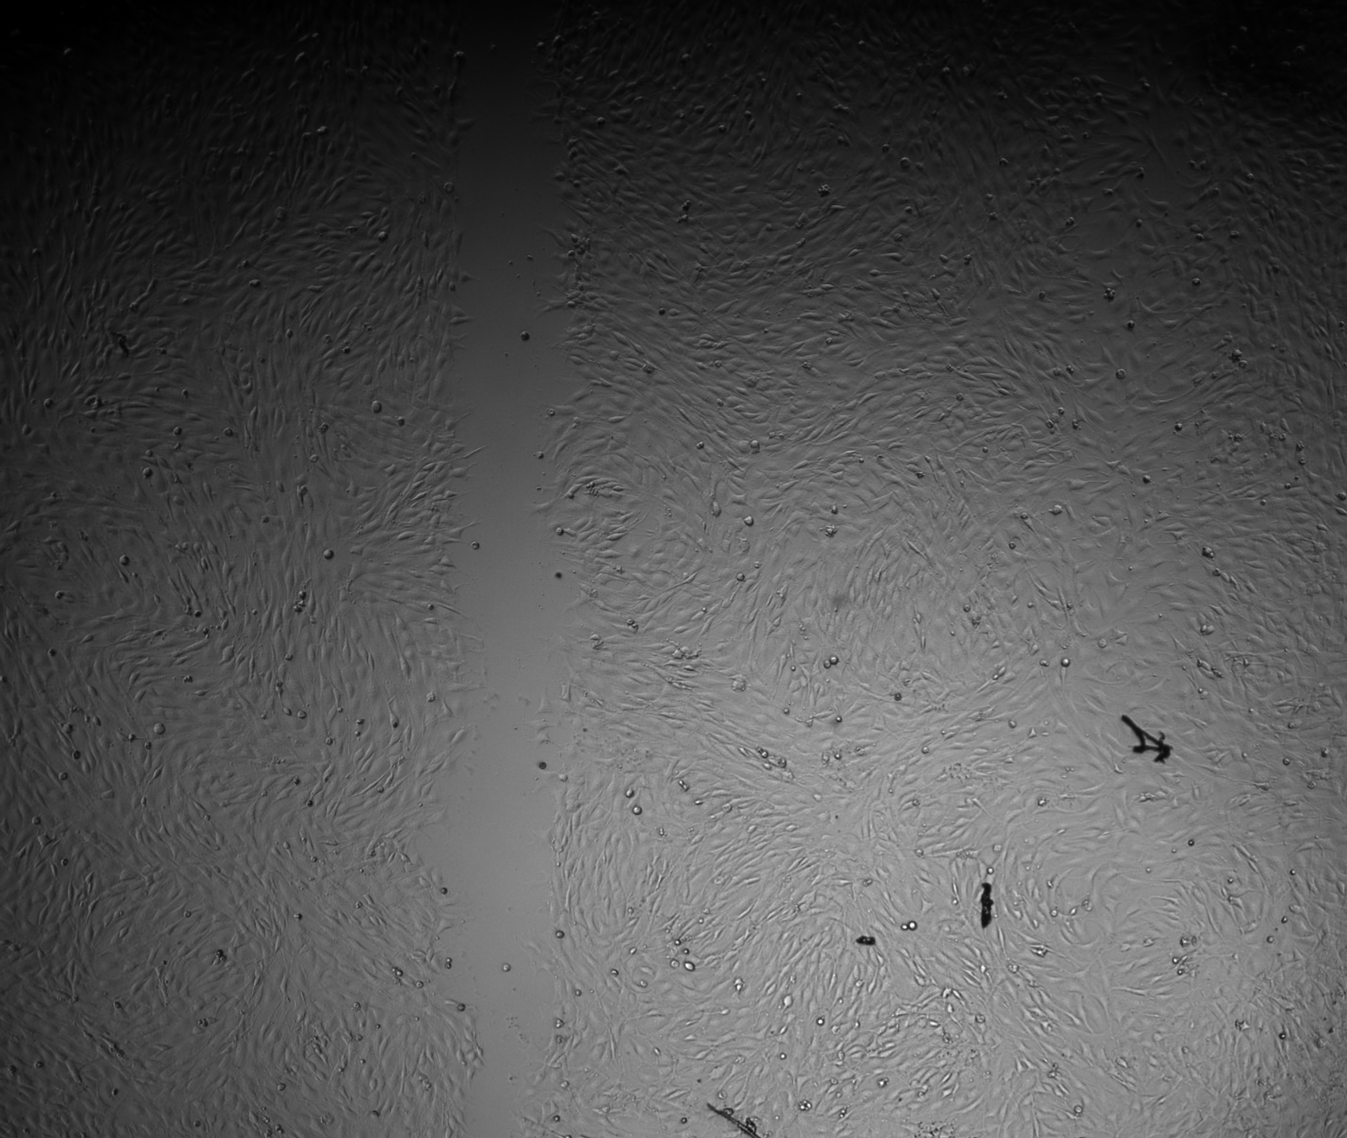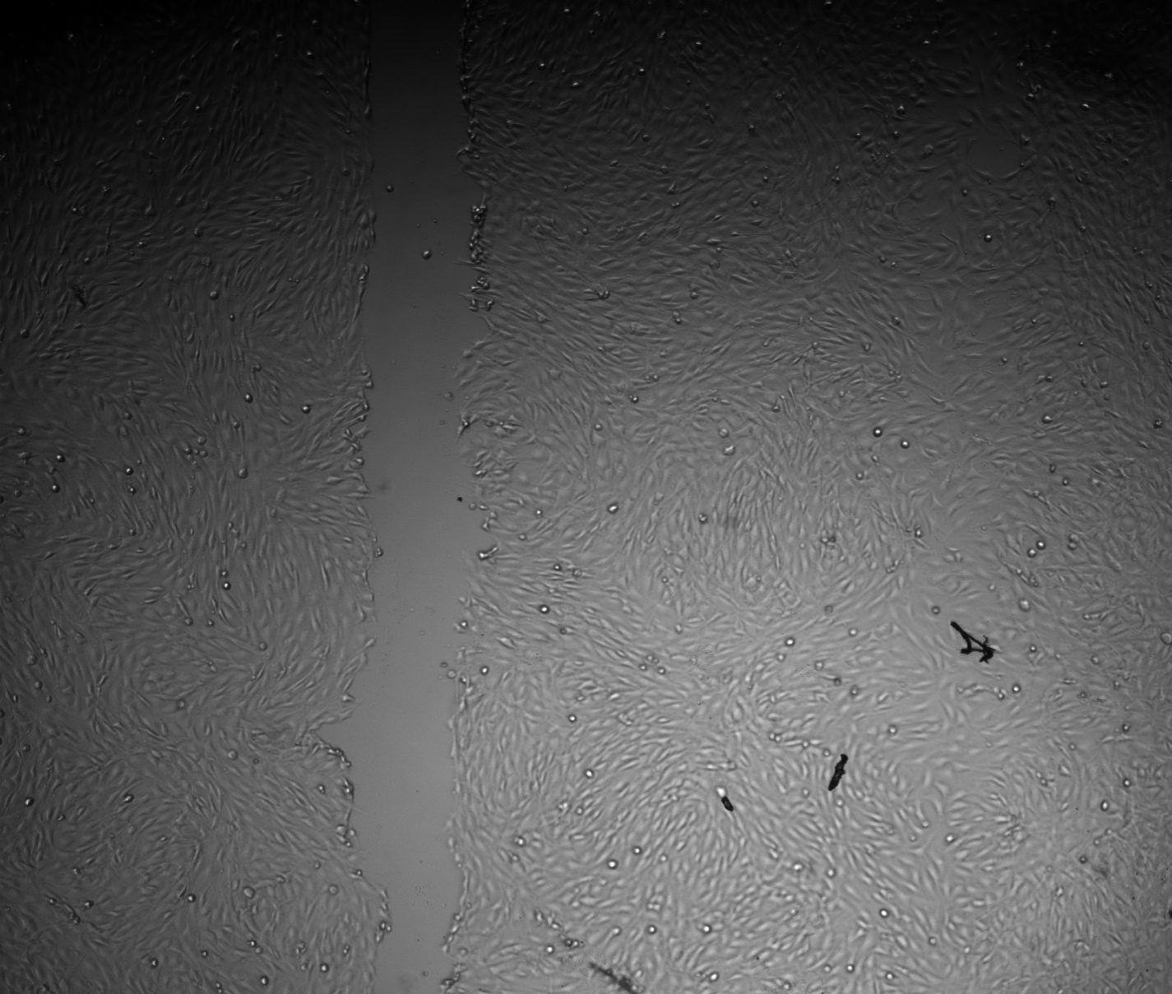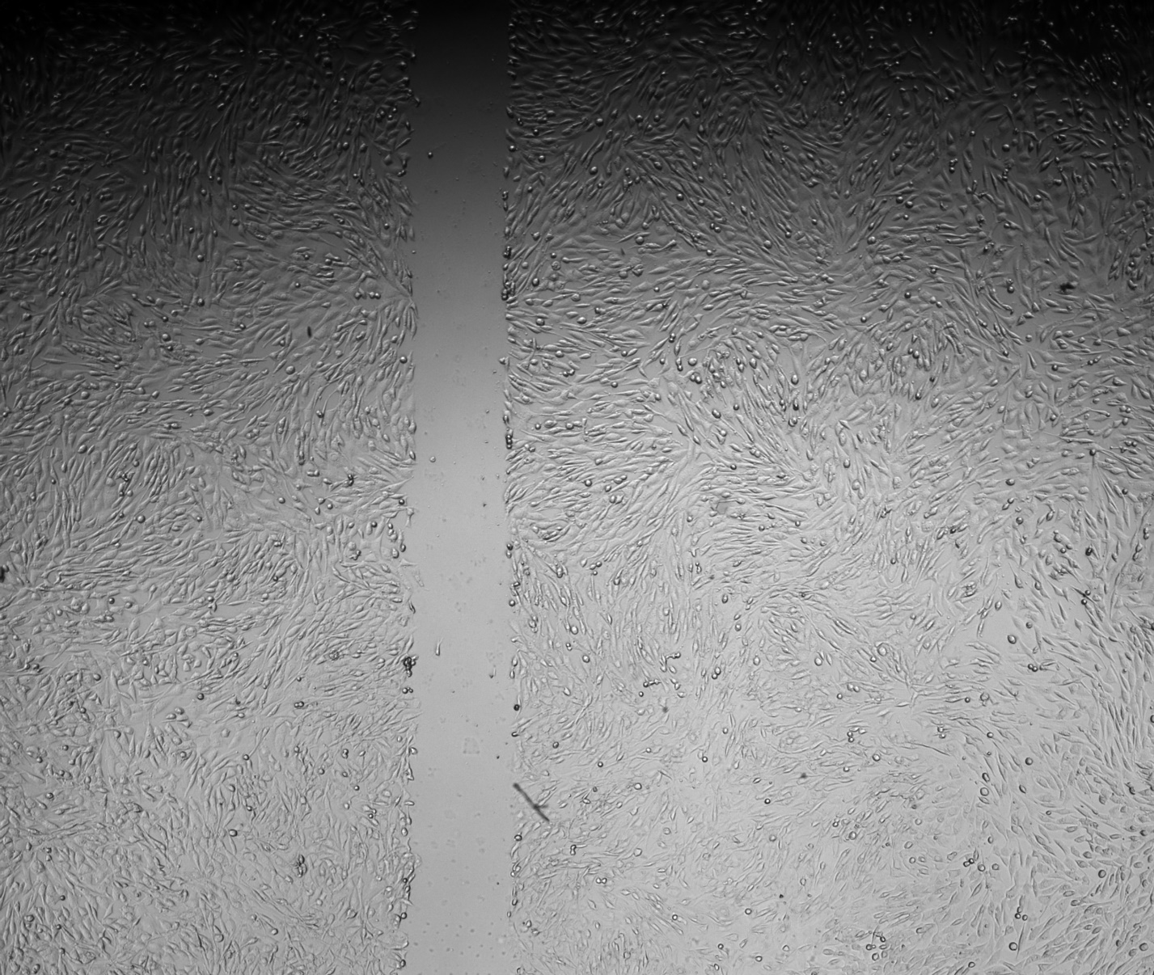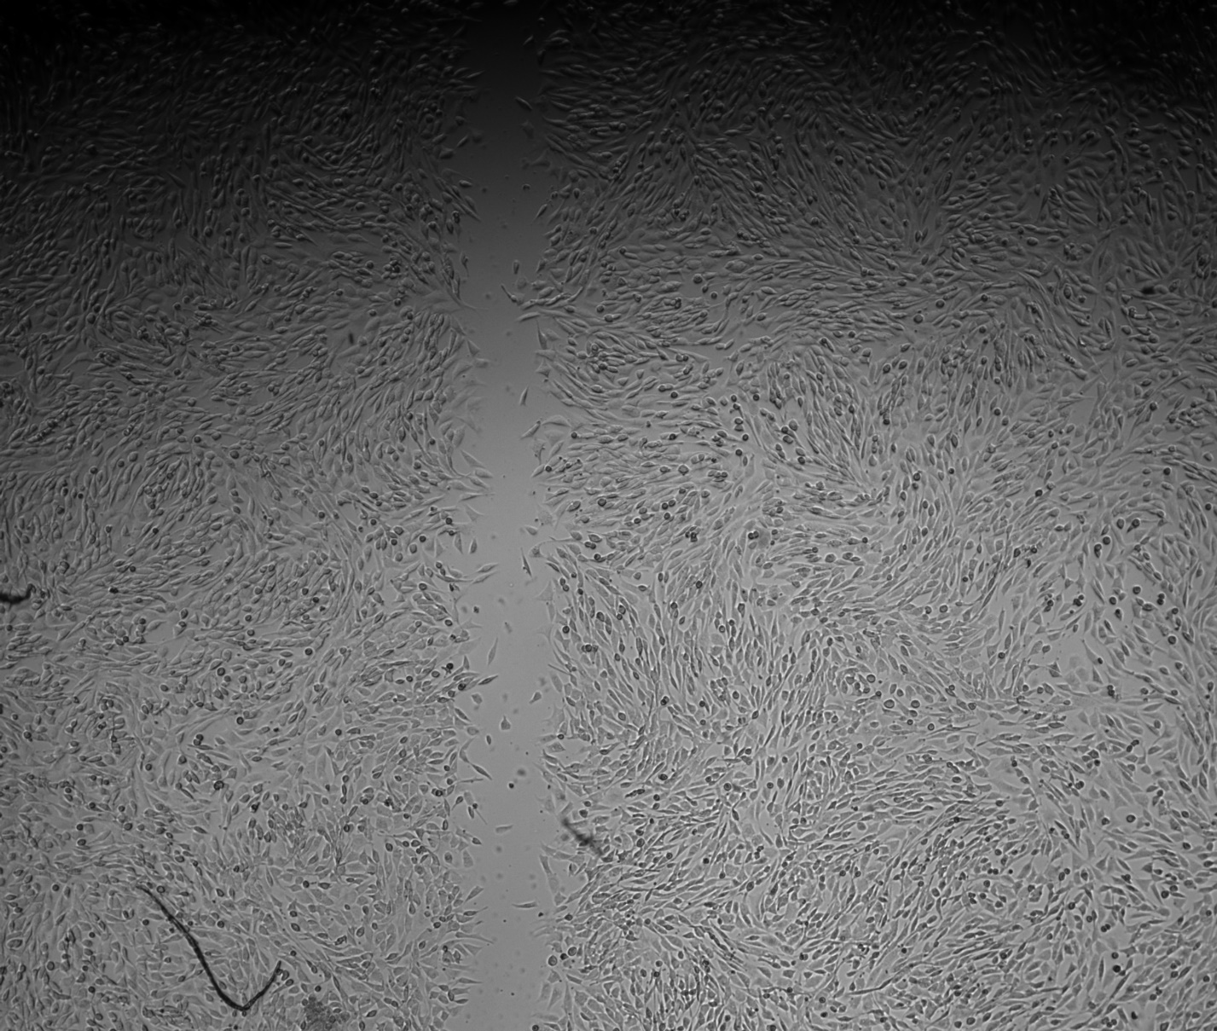

0 hours after scratch

4 hours after scratch

20μM GSK126

100 ng/mL Trichostatin A

(Figure 5: Fixed images of NIH-3T3 cells treated with a 20μM concentration of GSK126 (top) and 100 ng/mL TSA (bottom) immediately after and four hours after scratching)

# Work Remaining

*Table 1: Initial Project GANTT Chart*

|  |  |  |  |  |  |
| --- | --- | --- | --- | --- | --- |
|  | December | January | February | March | April |
| 1 – Aim 1 Validation |  |  |  |  |  |
| 2 – Aim 1 Baseline |  |  |  |  |  |
| 3 – Aim 2 Data Collection & Analysis |  |  |  |  |  |
| 4 – Aim 3 Experiment Replication |  |  |  |  |  |
| 5 – Aim 3 Strain Mapping |  |  |  |  |  |
| 6 – E-days Preparation |  |  |  |  |  |

For completion of aim 2 a full live analysis is still required using automated cell tracking to collect quantitative migration parameters. Beyond this, aim 3 was already quite ambitious initially assuming minimal setbacks would occur. However, with large delays in cell culture this semester, the strain mapping no longer seems feasible. Instead, we plan to update the third aim for this project to be the *creation of a predictive mechanobiological model* where nuclear mechanics are an input parameter for a migration output. An updated timeline with these changes is reflected below in table 2.

*Table 2: Revised Project GANTT Chart*

|  |  |  |  |  |  |
| --- | --- | --- | --- | --- | --- |
|  | December | January | February | March | April |
| 1 – Aim 1 Validation |  |  |  |  |  |
| 2 – Aim 1 Baseline |  |  |  |  |  |
| 3 – Aim 2 Data Collection & Analysis |  |  |  |  |  |
| 4 – Aim 3 Modeling Research |  |  |  |  |  |
| 5 – Aim 3 Model Creation |  |  |  |  |  |
| 6 – E-days Preparation |  |  |  |  |  |